Steve Vai: How to be Successful
There are three things usually that I find are the burning questions that most young musicians have: How do I make it in this business? How do I make a record, get it out there, get people to hear it, and become successful. I think the first thing is that we need to identify with what it is we really want. Because whatever it is you really want, that’s what’s going to come out. The thing you are most comfortable with, that you do the best because that’s what you are going to do best.
Like me. I’ve got strengths and I’ve got weaknesses. I don’t work on my weaknesses. I ignore them, and I cultivate my strengths. The level of achievement that we have at anything is a reflection of how well we were able to focus. Because the only thing that is holding you back is the way you are thinking. Pick a song in your head that you would like to be able to play; something that’s within your reach. Imagine right now that song. Picture yourself playing it. That’s the first part of the exercise in achieving it.
Now as you’re picturing yourself playing it, imagine what it sounds like. Perfect. See and hear yourself playing it elegantly and beautifully whether it’s an aggressive metal track. Whatever it is, see yourself playing Beginning to end, perfectly with confidence. The more you are able to crystallize that vision, the more you are going to become a self-fulfilling prophecy.
Let’s talk about practice and let’s talk about spending time to reach your goals. Because I know the complaints: we have obligations in life, we have responsibilities, we have so many other things that we have to do. How do we find time to play the instrument? I recommend that you pick a time that yours. A time when you shut off the cell phone, shut off the telephone, turn off the Internet, and sit and focus on your goal.
Whenever you get discouraged, go to the big picture. Go back to that place of excitement. That’s how you get through it. You go to the big picture. You go to the chief aim because it’s so crystallized in your head. When you feel “I can’t do this,” you go back to that picture, and you can see yourself doing it.
Now you’ve got to put the work in. It’s no work; there’s no work involved because it’s all a joy. Because you know you’re reaching your goals. You know what I saying? I never worked a day in my life in this business, I mean with the guitar. I never struggled. Honestly, I’ve had a lot of challenges, and I’ve been through a lot, but when it came to my feelings about what I do and my success so to speak, I never struggled a day in my life because for me playing guitar was my juice.
So you break it down piece by piece by piece. And if it’s a classical song you go one bar at a time, and then you go to the next bar, and then you go to the next bar. Eventually, you’ll be able to play through this music. You won’t play it great, but you’ll be able to through it. That’s when you gotta stick at it, stick at it, and keep playing it because at first it’s getting your fingers in shape. But then, once you own this piece of music, then it flows. Then it’s like this whole other thing comes over. It’s this ability to become the music.

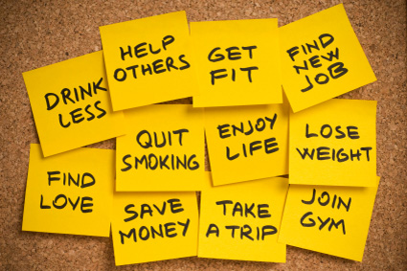

Discussion Questions

1. Steve Vai said: “I don’t work on my weaknesses. I ignore them, and I cultivate my strengths.” Do you agree with Steve’s philosophy concerning weaknesses?
2. Do you agree with Steve Vai’s advice for how to become successful?
3. What are some goals you would like to accomplish this semester and this year? How will you accomplish those goals?
4. What were your goals a year ago? Did you achieve them?
5. What do you think your goals will be 5 and 10 years in the future?
6. Do you have any goals related to music?

